Maven Clean

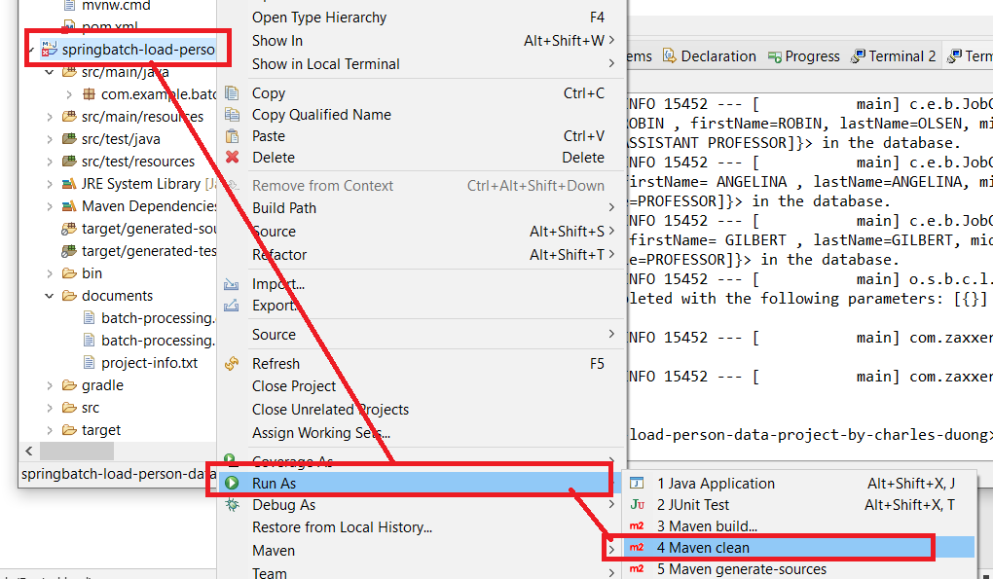

Maven Clean - OK

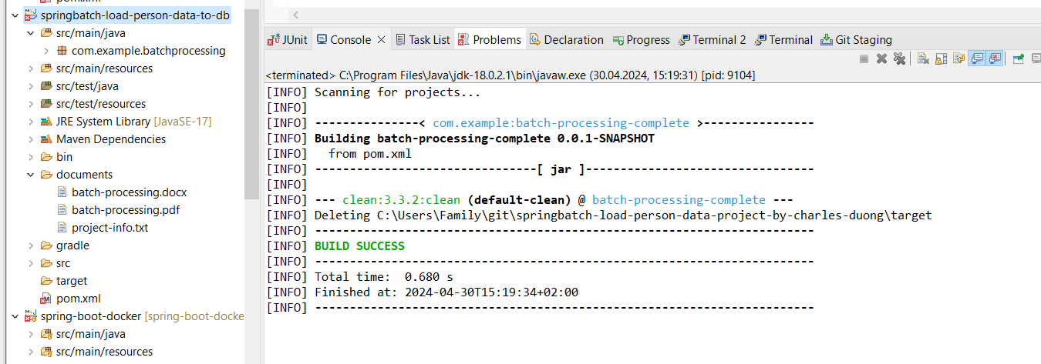

Maven Install

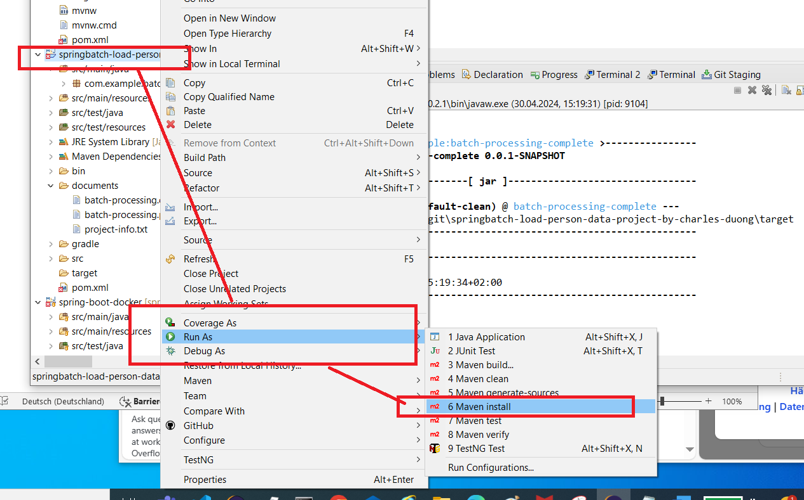

Maven Install - OK

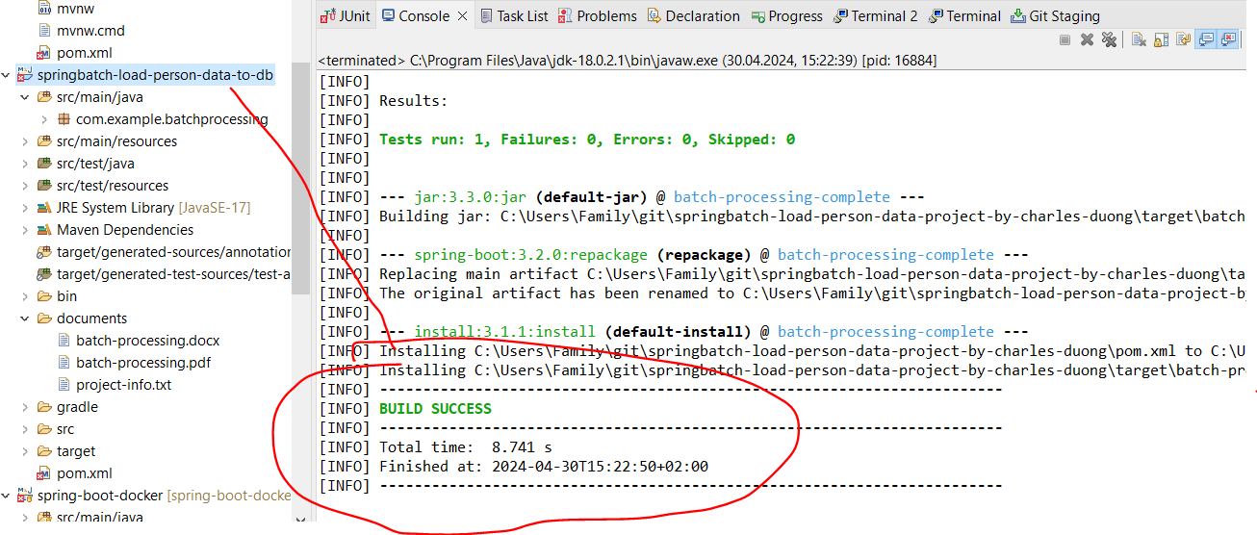

JAR is created - OK

JAR: batch-processing-complete-0.0.1-SNAPSHOT.jar

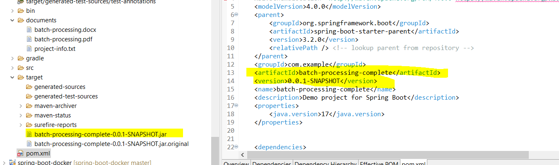

RUN JAR

On Terminal run: java -jar target/batch-processing-complete-0.0.1-SNAPSHOT.jar

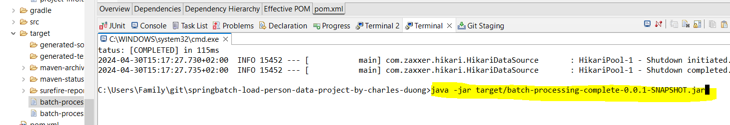

person-data.csv

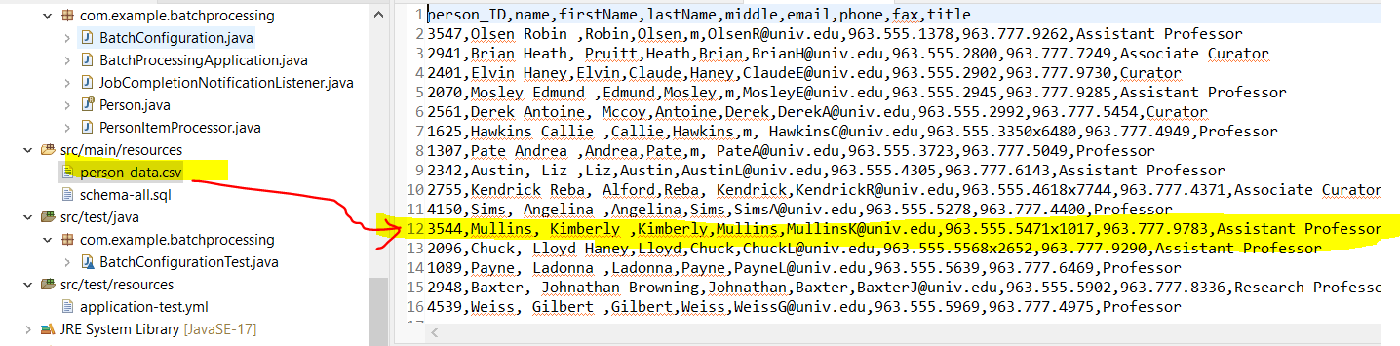

person-data.csv file is loaded and the data are saved in the people table (database) successfully. - OK

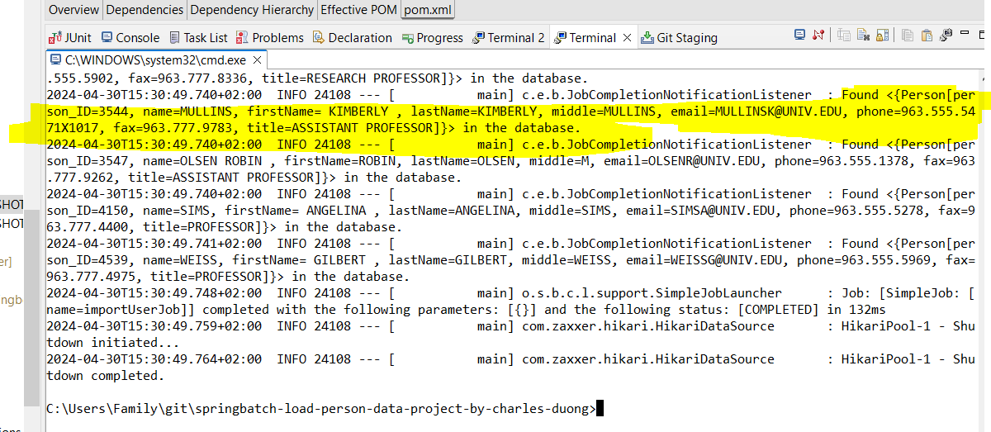

people table

